LLUNA

Transforming Academic Administration Through Human-Centered Design
Role: UX Research & Product Design
Project Type: Academic Management Ecosystem
Organization: Atria Institute of Technology
Research Participants: 100+ Faculty Members
Product Reach: 3,000+ College Stakeholders
Platforms: Lluna Evalo · Lluna Student · Lluna Admin

01. Project Overview
Academic administration at my college relied heavily on paper-based processes and spreadsheets. Managing student marks, attendance, examination evaluation, room allocation, and evaluator assignments required faculty members to coordinate across multiple sheets and manually maintain records.
The problem extended beyond digitizing paperwork. Faculty members were dealing with significant cognitive overhead from switching between spreadsheets, tracking evaluation assignments, allocating rooms, and maintaining student records.
The objective was to transform these fragmented workflows into a connected digital ecosystem that served the different needs of faculty members, students, and academic administrators.
This led to Lluna, an integrated academic management ecosystem designed around three primary user groups, each with distinct responsibilities and information needs.

02. Understanding the Problem
I started by speaking directly with the people using these processes every day.
I conducted 100+ faculty surveys and interviews to understand where existing workflows were breaking down, which administrative tasks consumed the most time, and what made managing academic information difficult.
Rather than assuming that a digital spreadsheet would solve the problem, I focused on understanding the underlying workflows and the cognitive load associated with them.
The research highlighted several recurring challenges:
- Fragmented information: Marks, attendance, and evaluation details were maintained across different sheets and records.
- Complex allocation workflows: Assigning evaluators and rooms required manually coordinating multiple constraints.
- High cognitive load: Faculty members had to navigate large spreadsheets and repeatedly cross-reference information.
- Limited visibility: Students and HODs lacked a unified interface to access the information relevant to them.
These findings helped establish a key design direction: each stakeholder needed an interface designed around their specific tasks rather than a single overloaded administrative dashboard.
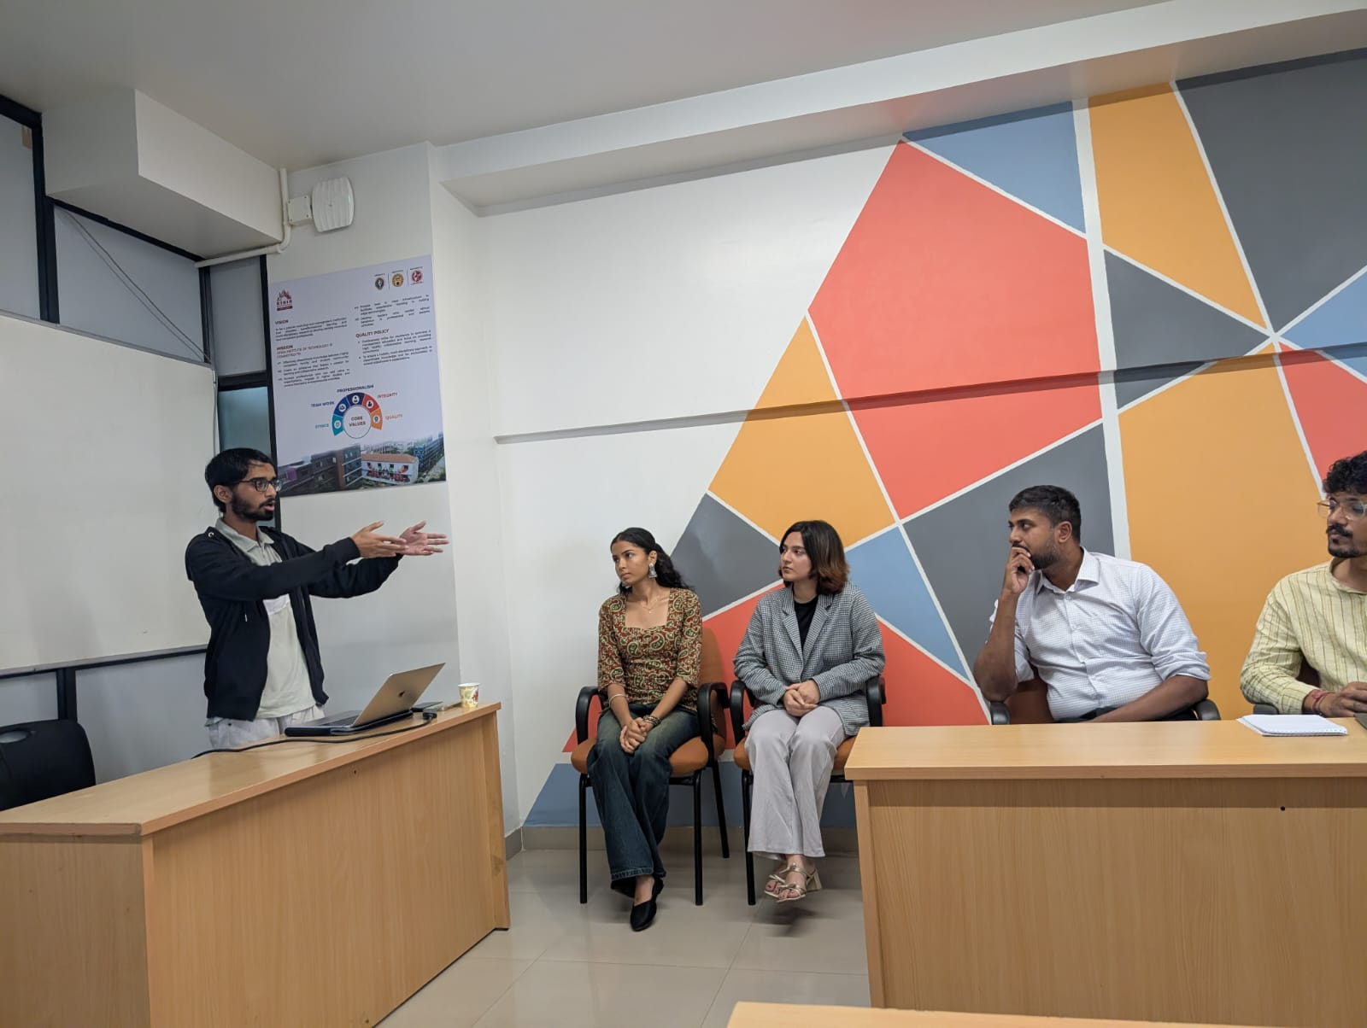
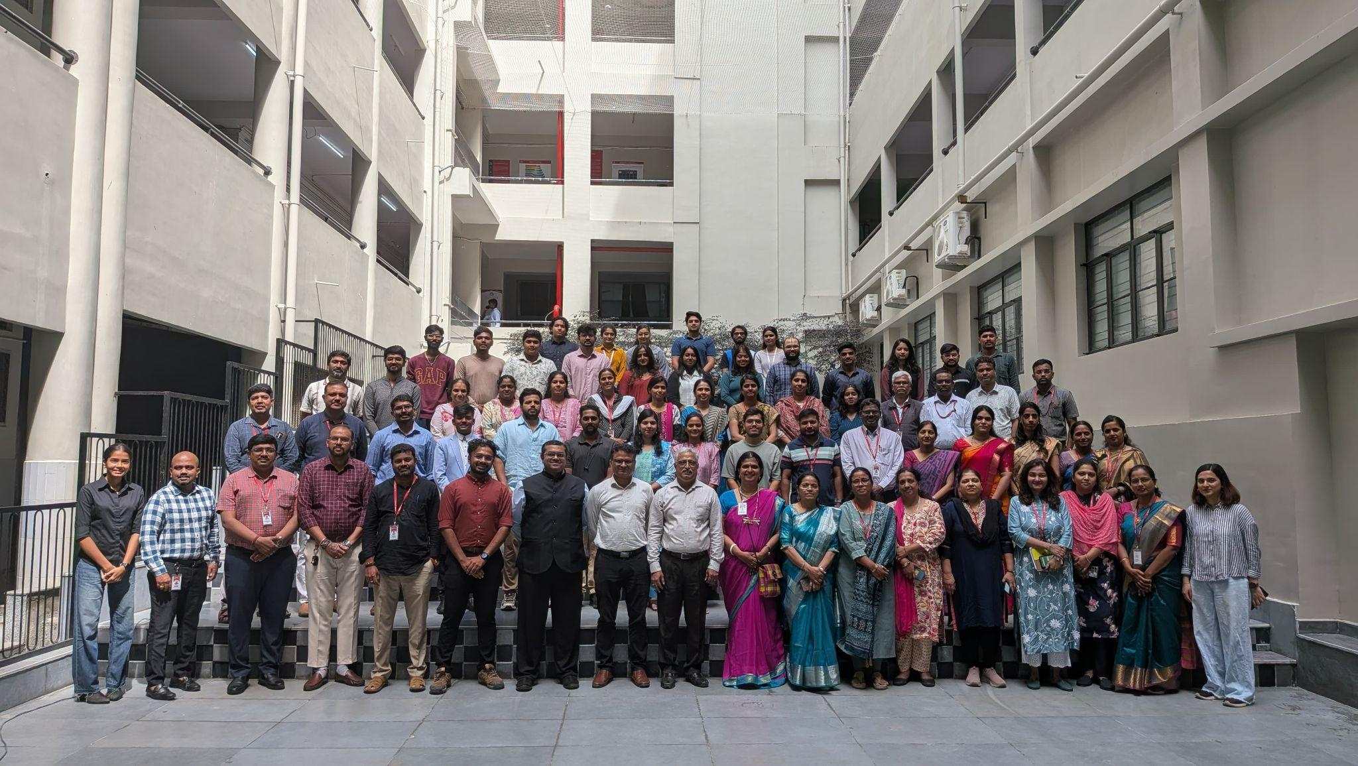
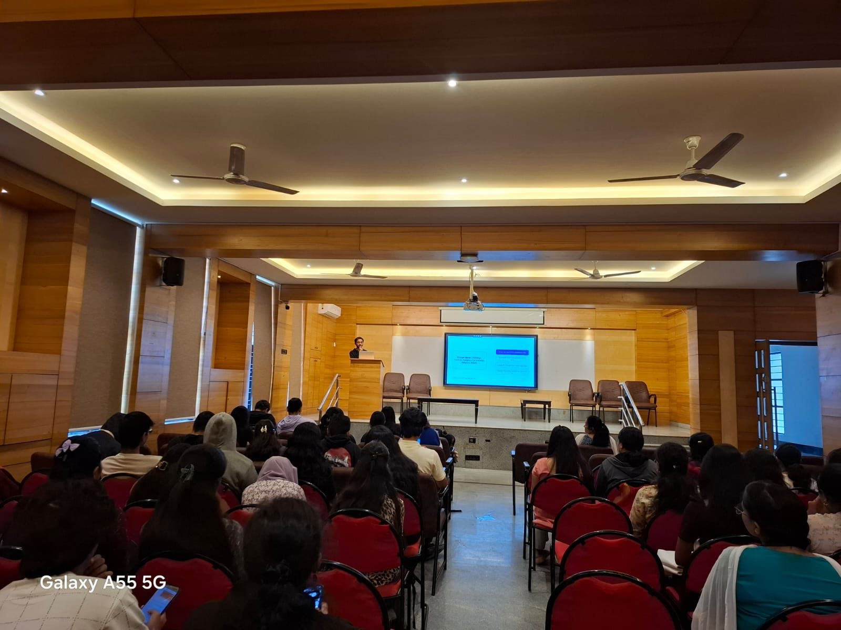

03. Designing and Validating the Experience
With multiple stakeholder groups involved, the challenge was to organize information without introducing another complicated system.
I worked on structuring the ecosystem around three distinct experiences:
Lluna Evalo — Faculty Experience
Designed for faculty members to manage student marks, attendance, and evaluation-related workflows. The goal was to reduce dependency on paper records and spreadsheets while making frequently performed academic tasks easier to access.
Lluna Student — Student Experience
Designed to give students direct access to their academic information, including marks and allocated evaluation rooms. Instead of depending on faculty announcements or manually checking notices, students could access relevant information through a dedicated interface.
Lluna Admin — HOD & Administration Experience
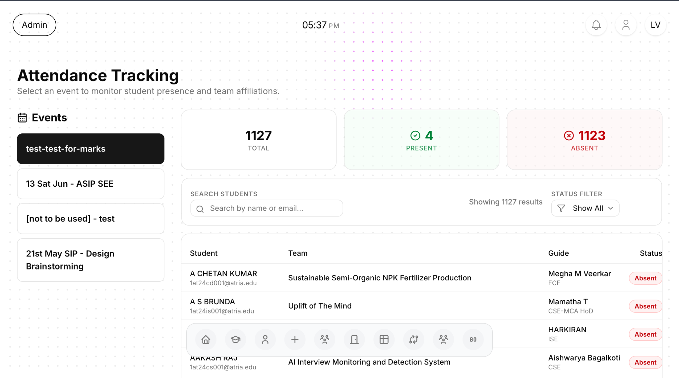
Designed for academic administrators and Heads of Departments to view and manage marks and academic information across the institution, providing a more centralized view of departmental activity.
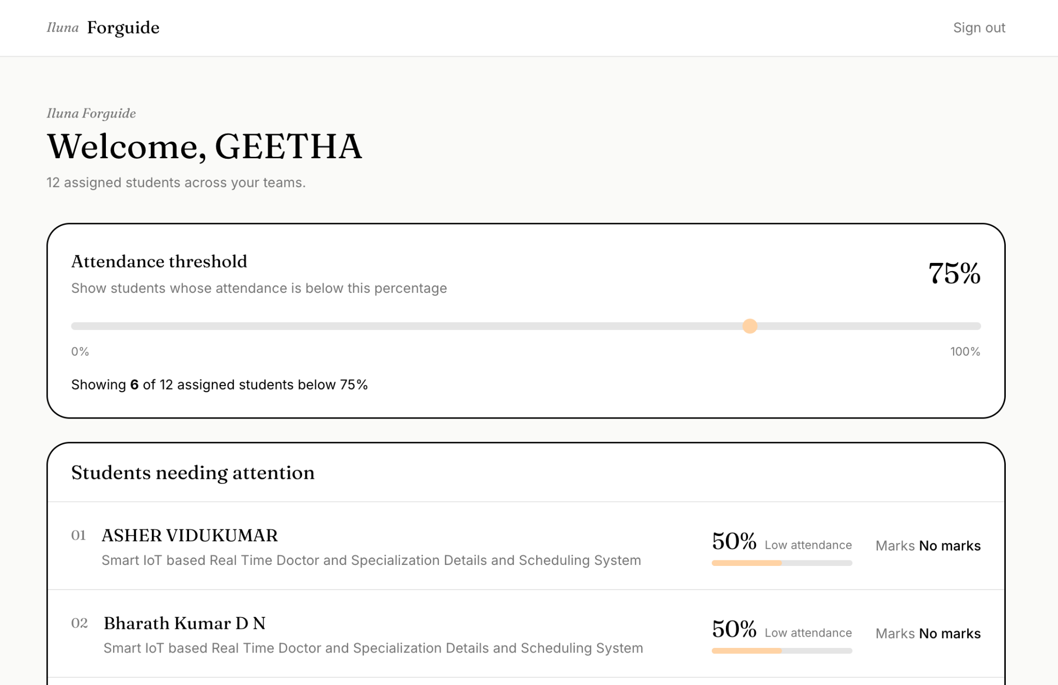
Visit : https://lluna.in

04. AI-Assisted Design Validation
One of the challenges was determining which interface layouts would be easiest for faculty members to understand and use.
Given the rapid development environment, I explored an AI-assisted A/B testing workflow to evaluate alternative interface layouts and identify which design direction offered a more intuitive experience.
Rather than relying entirely on personal design preferences, the intention was to use comparative feedback to inform interface decisions.
This helped accelerate design iteration while keeping usability and stakeholder requirements central to the process.
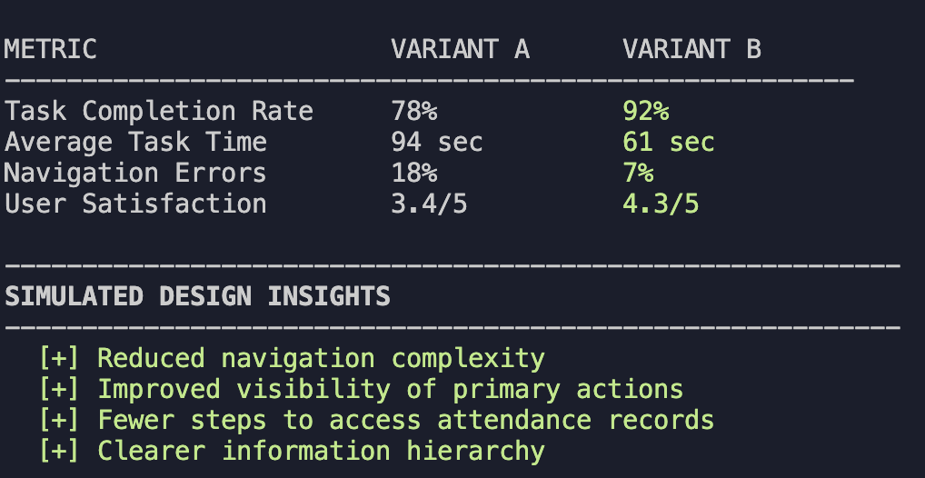

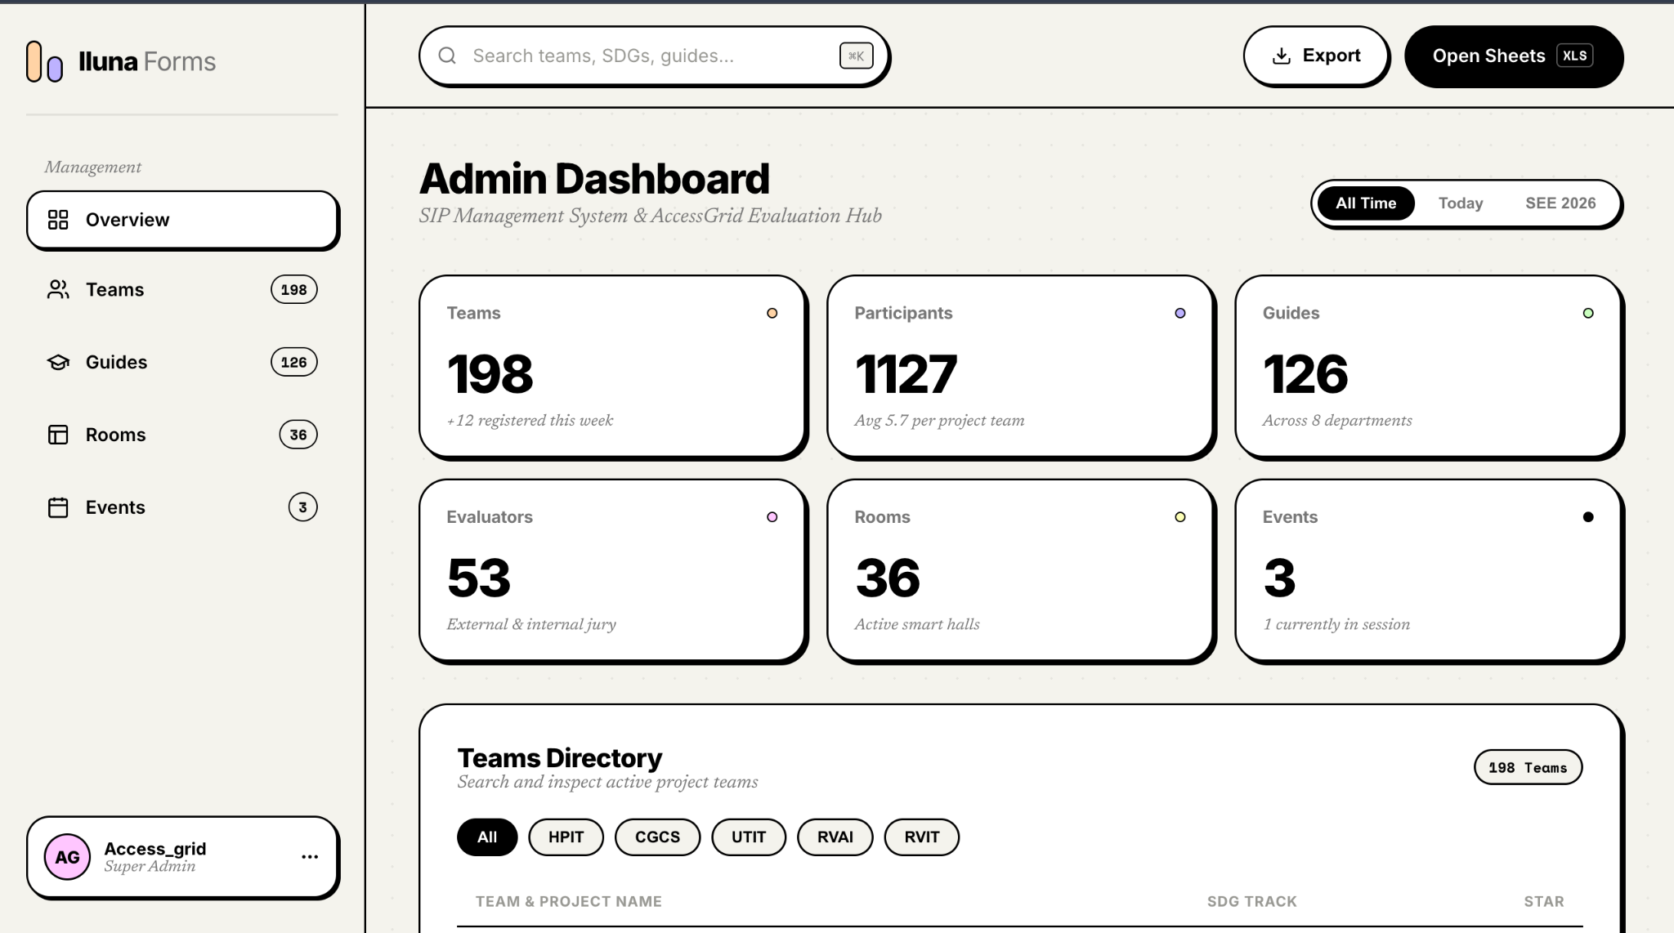

05. Rapid Iteration & Deployment
The project operated in a fast-paced environment where requirements evolved through frequent interactions with faculty members and administrators.
Design decisions had to account for real operational constraints while remaining practical to implement. I worked through rapid feedback cycles, refining layouts and workflows as the ecosystem developed.
The focus was not simply to reproduce existing paper-based processes digitally, but to reduce unnecessary steps, improve information accessibility, and create consistent experiences across the different stakeholder interfaces.
The three products were developed and deployed as a connected academic management ecosystem.

06. Outcome & Impact
Lluna was successfully deployed and adopted across the college management ecosystem, reaching 3,000+ stakeholders.
The platform brought previously fragmented academic workflows into interconnected digital experiences:
- Faculty members could manage marks, attendance, and evaluation-related activities through Lluna Evalo.
- Students could access their marks and allocated evaluation rooms through Lluna Student.
- HODs could access academic information through Lluna Admin.
The project demonstrated the importance of designing around the actual responsibilities and constraints of different user groups rather than forcing everyone into the same interface.

Key Contributions
- 100+ faculty surveys and interviews to identify workflow bottlenecks.
- Multi-stakeholder workflow research and information architecture.
- Three interconnected product experiences for faculty, students, and HODs.
- AI-assisted A/B testing for interface layout validation.
- Rapid design iteration and deployment.
- 3,000+ stakeholders reached through institutional adoption.
Tools & Technologies: Figma · AI-assisted A/B Testing · Product Design · UX Research

